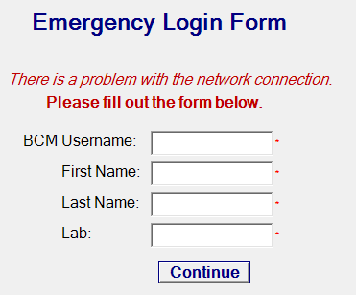
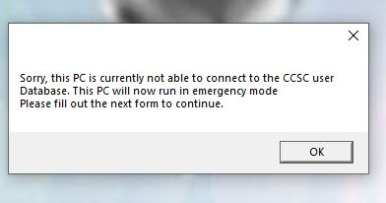
Emergency Login screen- cannot log in
- Press Alt+Tab (brings up open windows)
- Click “X” on the log in screen
- Open Google Chrome
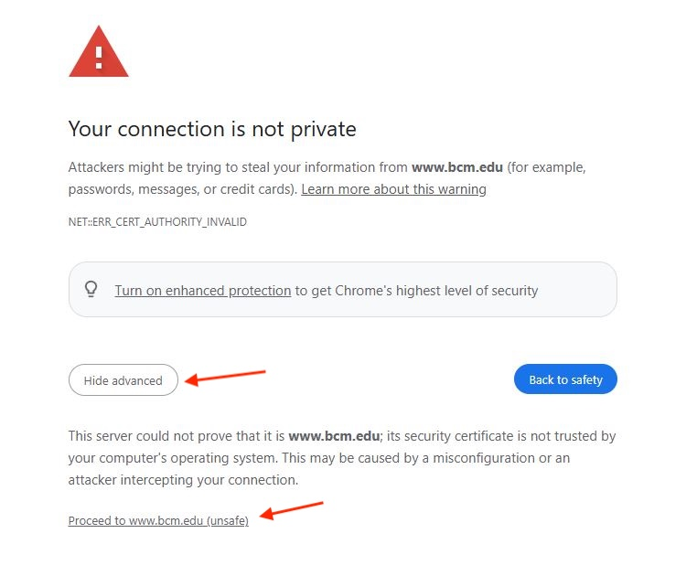
- Type in browser: https://www.bcm.edu (you must type every letter and symbol exactly as shown)
- On Warning screen, click advanced and “proceed to www.bcm.edu (unsafe)”

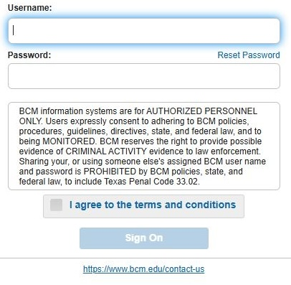
- The next screen will have you sign in to BCM using your ECA (agree to terms and conditions) It will not remember your credentials or be able to access any of your files.

- The internet should now be connected.
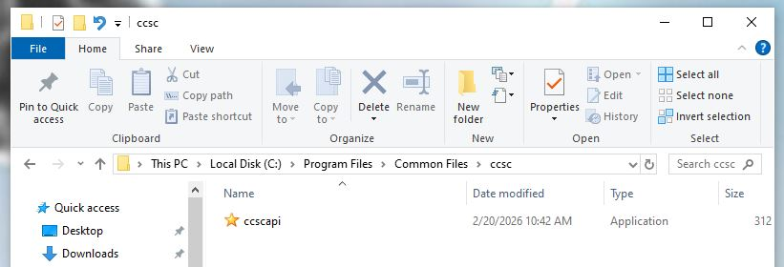
If you need your shared drive, open C://Program Files*/Common Files/ccsc/ccscapi.exe. This should open the grey screen again. Log in, it should now be able to log in and connect the shared drive.
*could also be Program Files (x86)

