Surgery T32 Training Program Letter of Intent

Please provide the information below so we can help you choose a mentor and plan a full application. This letter of intent should be submitted as soon as possible. Full applications will be due by 5:00pm on Friday, March 1, 2019. Selections will be made in early May.

Format of Surgery T32 Letter of Intent

Applications should be single-spaced with ½ inch margins and 11-point, Times New Roman or Arial font.

1. A cover sheet that provides the following information (all needed for our NIH program annual report):
  - Your name
  - Number of publications (in peer-reviewed journals, excluding abstracts)
  - Number of first-authored publications
  - The institution from which you received your doctoral degree
  - Whether you are a US citizen or permanent resident

2. Past experience and career goals (1 page maximum, start on a new page)

  - Personal statement – Describe your career goals, both short and long term, and how mentored training in cardiovascular research would help you achieve those goals. In the personal statement, clarify which of the three T32 training tracks best suits your career goals and research interests. (See figure below for the three training tracks).
  - Education – Describe your relevant prior education (including clinical surgical training).
  - Prior research experience – Describe your prior research experience and how this relates to your proposed project.
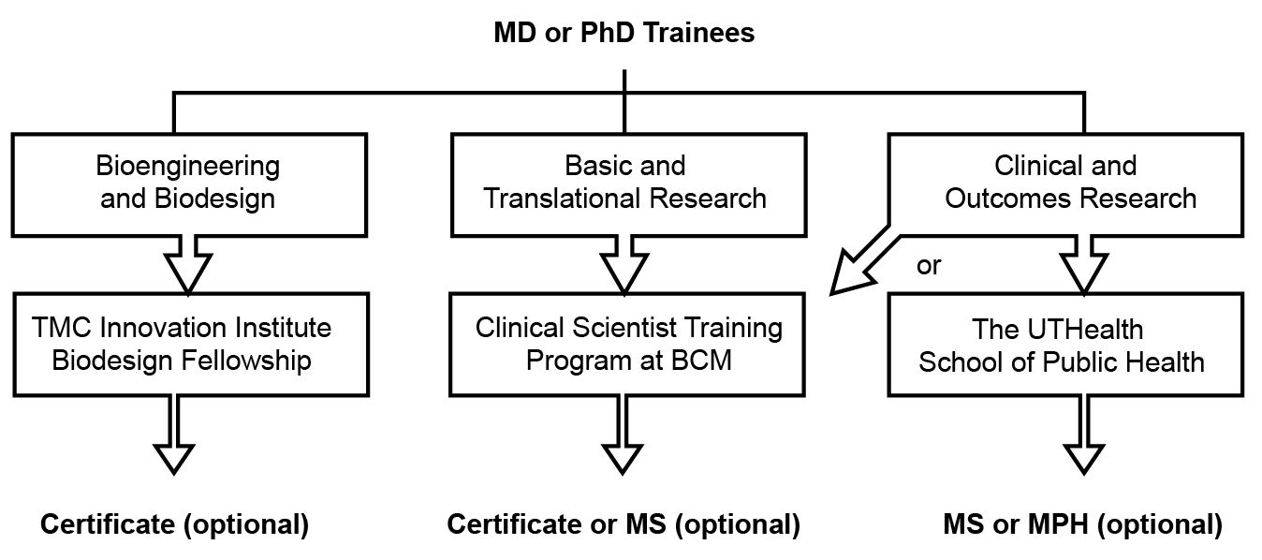

https://www.bcm.edu/departments/surgery/divisions/cardiothoracic-surgery/education/t32-research-training-program

